Title Personal Health and Hygiene
Purpose Proper hygiene is essential to good health. Students should be taught and shown correct hygiene. The teacher can role model hygiene by coming to class each day clean, washing of hands, etc. The teacher can also teach proper hygiene, as maybe the student does not receive lessons or sees role modeling of proper hygiene at home.

Grade Level k-2

Learning Targets Cognitive: Students will comprehend concepts related to health promotion and disease prevention to enhance health. Students will show this in their reflections, drawings, and through their communication with peers and the teacher.
Affective: Students will demonstrate the ability to practice health-enhancing behaviors and avoid or reduce health risks. Students will show this by demonstrating proper hygiene, making posters, and going into the community.

EALRs. NHES
Health and Fitness
1.3 Understands the components of health-related fitness and interprets information from feedback, evaluation, and self-assessment in order to improve performance.

1.3.1 Understands basic vocabulary and components of health-related fitness.

1.4 Understands the components of skill-related fitness and interprets information from feedback, evaluation, and self-assessment in order to improve performance.

1.4.1 Understands basic vocabulary of the components of skill-related fitness.

2.1 Understands foundations of health.

2.1.1 Understands dimensions and indicators of health

2.3 Understands the concepts of prevention and control of disease.

2.4 Acquires skills to live safely and reduce health risks.

4.1 Analyzes personal health and fitness information.

Communication
3.1 Uses knowledge of topic/theme, audience, and purpose to plan presentations

3.1.1 Understands how to plan and organize effective oral communication and presentation

3.3 Uses effective delivery.

3.3.1 Applies skills for delivery of effective oral communication and presentations.

Standard 1 Students will comprehend concepts related to health promotion and disease prevention to enhance health.

Standard 4 Students will demonstrate the ability to use interpersonal communication skills to enhance health and avoid or reduce health risks.

Standard 7 Students will demonstrate the ability to practice health-enhancing behaviors and avoid or reduce health risks

Standard 8 Students will demonstrate the ability to advocate for personal, family, and community health.

Lesson
PROJECT OVERVIEW

Description
The Project Overview section is intended to give a general conception of the
Health Care: Making Hygiene Kits Service-Learning curriculum. It will take you five weeks to complete the project. Each week follows the Service-Learning process of meeting a local community need; learning information on an issue/topic; planning, preparing, and conducting service; and reflecting and celebrating the results. Within each week there are two or three lessons. Each lesson identifies a theme and main activity to support it.

Week One—Establishing a Community Need

Lesson 1 Theme: Facts about basic grooming.
Main Activity: Draw a picture based on a fact.

Lesson 2 Theme: Why a hygiene kit is important.
Main Activity: Rank hygiene kit items in order of importance.

Week Two—Learning about Basic Hygiene

Lesson 1 Theme: Read story.
Main Activity: Oral reading/game playing.

Lesson 2 Theme: Learn about the role of a community-based organization (CBO).
Main Activity: Fill out the chart and discuss the CBO presentation.

Lesson 3 Theme: Learn about the role that local individuals play in assisting
migrant farm workers.
Main Activity: Write thank you letters to the guest speakers.

Week Three—Project Planning

Lesson 1 Theme: Plan your project.
Main Activity: Complete game and ranking exercises.

Lesson 2 Theme: Set up your Service-Learning project.
Main Activity: Create posters.

Week Four—Service

Lesson 1 Theme: Counting hygiene kit items and analyzing results.
Main Activity: Collect, tabulate and sort out Hygiene Kit items.

Lesson 2 Theme: Provide the service: Arrange hygiene kits in bags or baskets
Main Activity: Organize hygiene kits for distribution.

Week Five—Reflection and Celebration

Lesson 1 Theme: Project Evaluation.
Main Activity: Work on class thank you letter to the school.

Lesson 2 Theme: Celebrate the Service-Learning project.
Main Activity: Pass out certificates and plan a party.

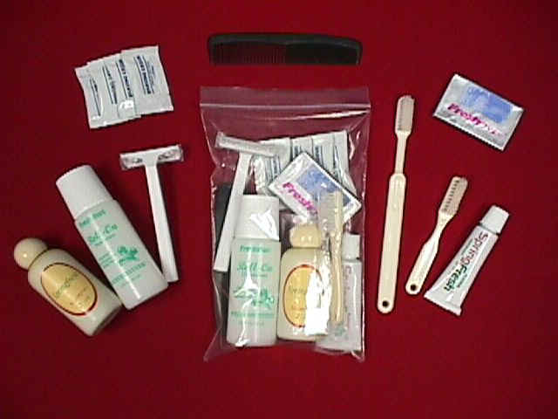
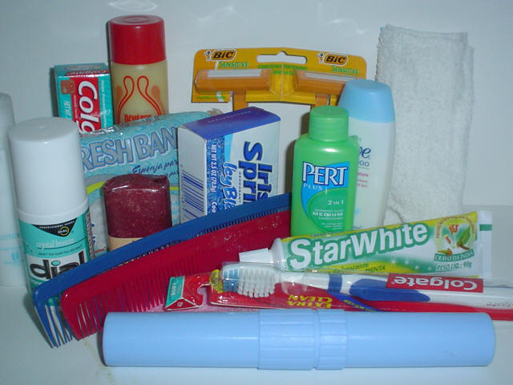
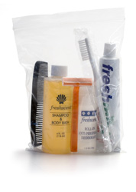

Curriculum Review Assignment
Mullan Road Elementary
First Grade
Text: gfhjg
Where district/teacher obtained their adopted Health Curriculum: jhghjgk
Health Topics covered during the year: jhkjhg

